
ÇANKAYA UNIVERSITY • CENG 382 WEB DEVELOPMENT

FINAL PROJECT REPORT

Project Name: LibMan

Name, Surname: Berke Erdem

Student Number: 201611019

31.05.2020

Contents ;

1-Project Information and Objectives…………………………….. 3
1.1-Project Information………………………….………… 3
1.2-Project Objectives……………………………………... 3
2-Project Implementation…………………………………………... 4
2.1-Database ……..………………………………………. 4
2.2-Database Diagram…………………………………….. 6
2.3-Data Flow Diagram……………………………………. 6
2.4-Class Diagram………………………………………….. 6

3-Project Results…………………………………………………….. 7
3.1-Login Page……………………………………………… 7
3.2-Sign Up Page…………………………………………… 7
3.3-Welcome Page…………………………………………. 8
3.4-Add Books Page………………………………………… 8
3.5-List Books Page…………………………………………. 9
3.6-JSon Download Button…………………………………. 9
3.7-Export Upload Page…………………………………….. 10

4-Conclusions…………………………………………………………. 10

1-Project Information and Objectives

1.1-Project Information :

The project consists of 2 homepages. One of them is the first home page. You will see 2 sections on this page. The first one is the page that will require you to log in. If you are a registered member, you can access your profile by entering your user name and password here. If you are not registered, you can register by entering the requested information (Username, name, surname, password, e-mail, date of birth and photograph) from the registration page and you can join the world of LibMan. What's in the LibMan world? After registration, you will be greeted with the 2nd Homepage. 2. The homepage consists of 5 sections in total. You will first see the Welcome page. You can see the people registered in LibMan world here and you can access your own information. LibMan isn't just that much. In the Add Books section, you can add the information of the book you want (title of the book, author, page number, picture, publisher, book summary, category, reading status). You can specify your reading status. You can then see the books you have entered by going to the List Book section. You can update, delete or see the details of the book you are reading from your online library at any time. In the other 2 sections, you can export the book lists by clicking on the Json Data button, or you can add the json file you select from your computer to the list book by entering the Export Data section.

1.2-Project Objectives :

One of our biggest goals in this project is to make people reading books fun and make them love reading books. An online library of their own and collectively mingle with people reading books. LibMan allows people to write down the books they want to read. It provides many opportunities such as the opportunity to read the summaries of the books you want to read. In short, LibMan turns you into a superhero about reading books.

2-Project Implementation
2.1-Database ;

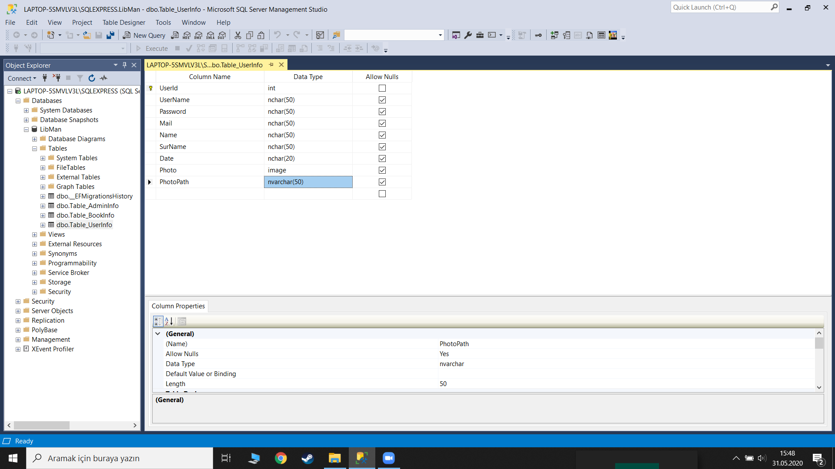

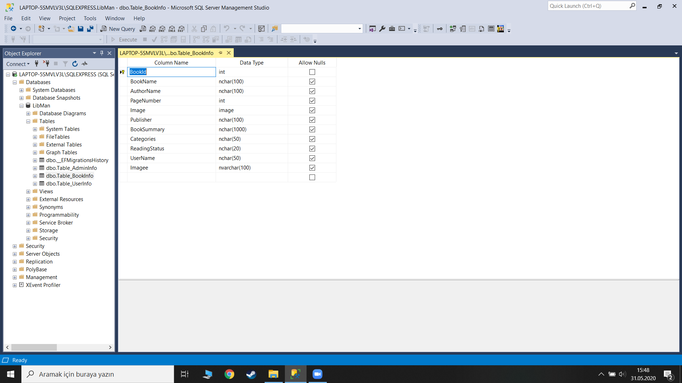

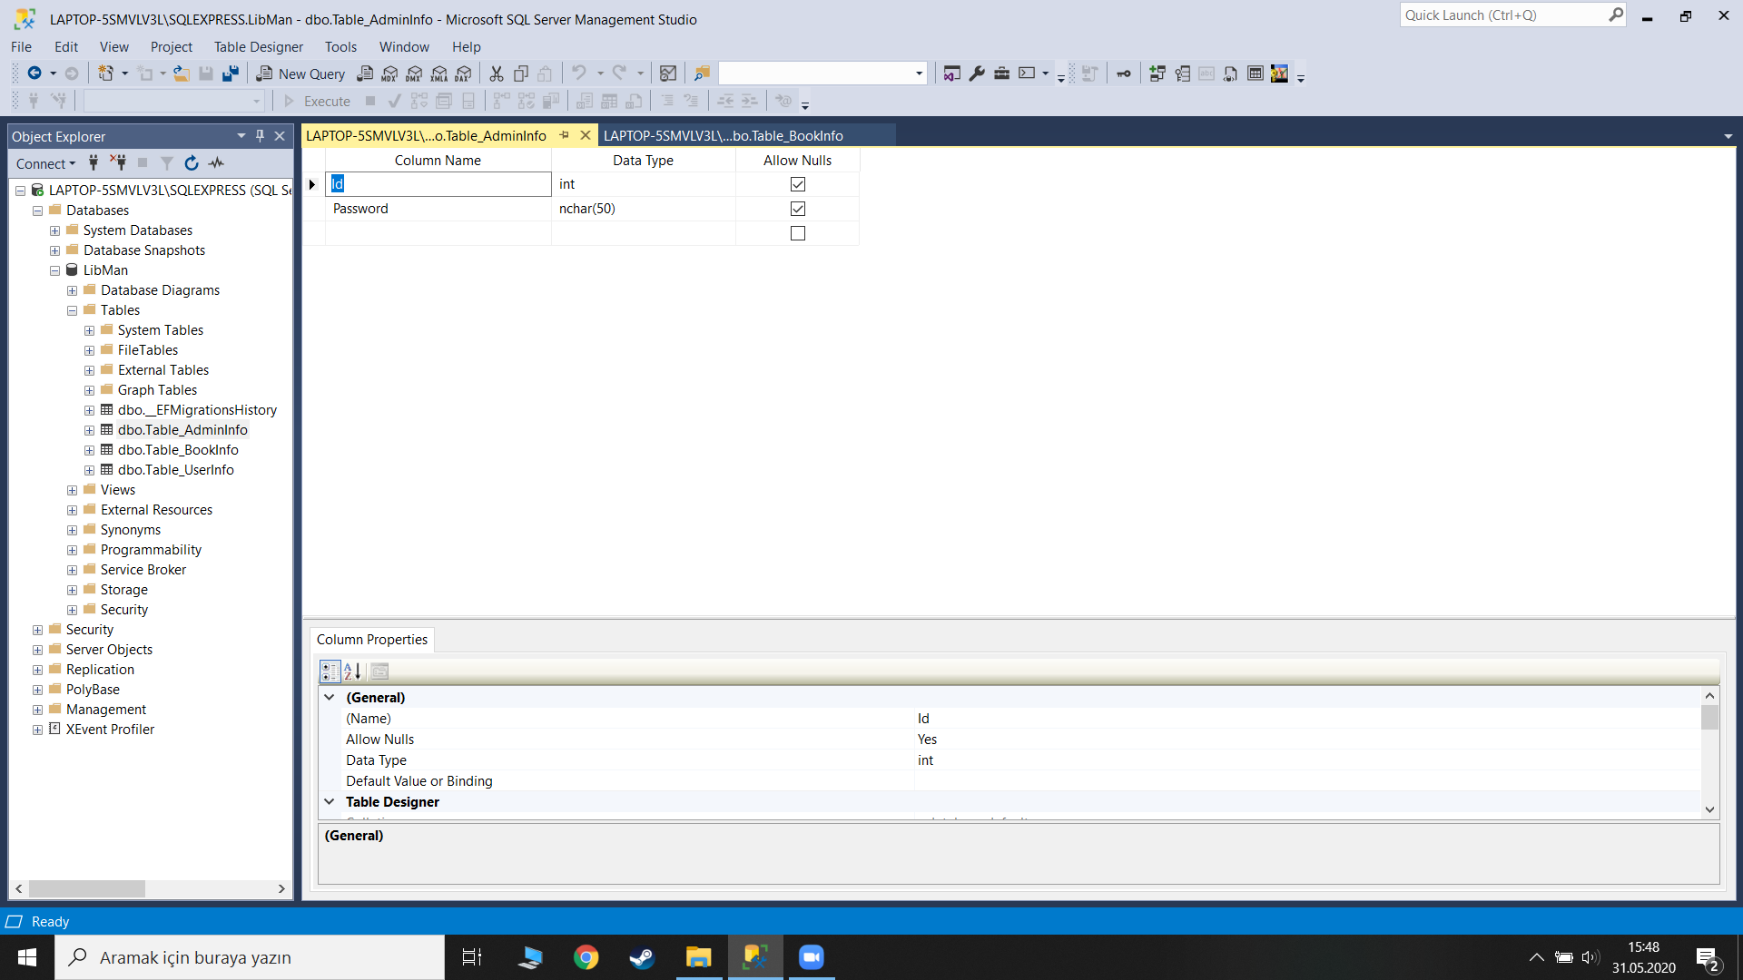

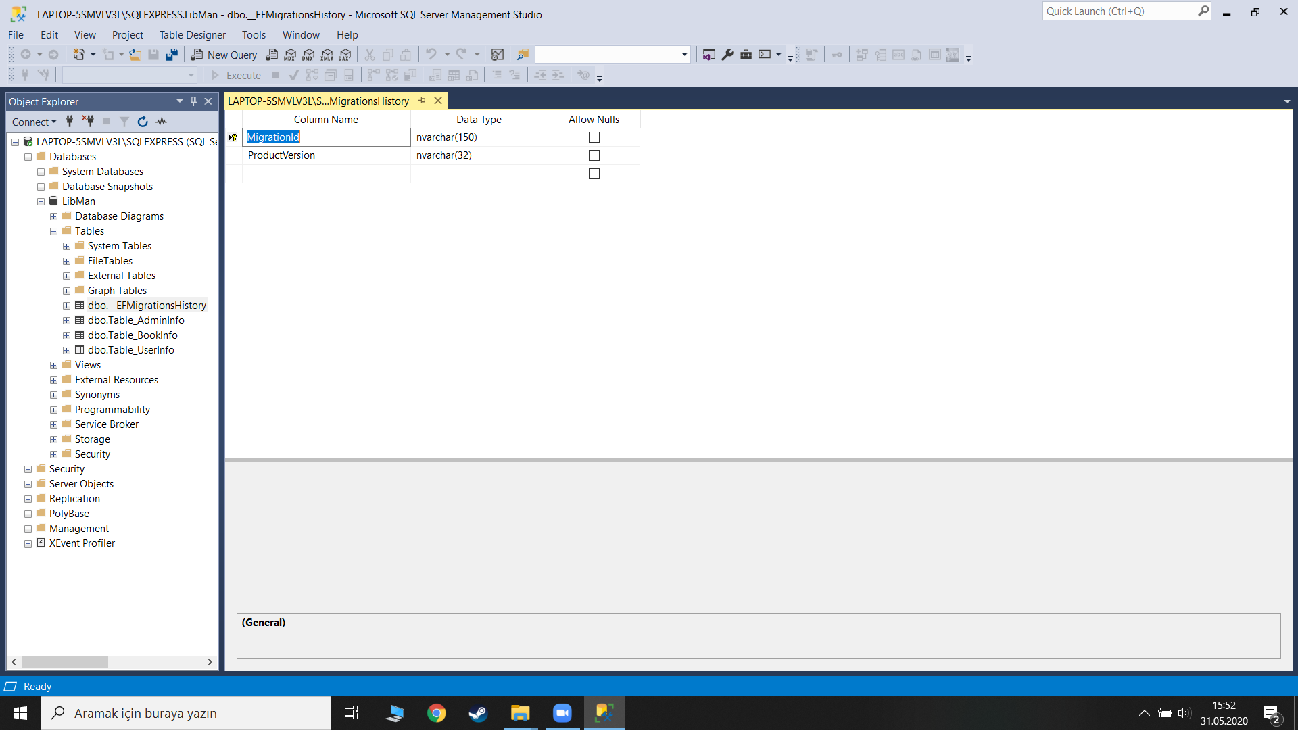

2.2-Database Diagram ;

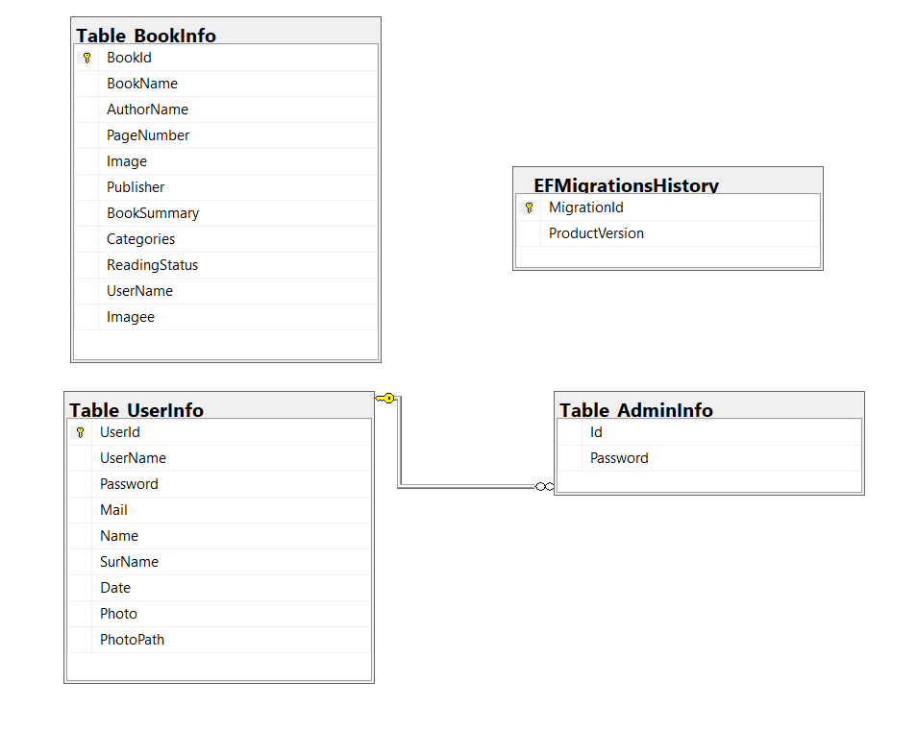
2.3-Data Flow Diagram ;
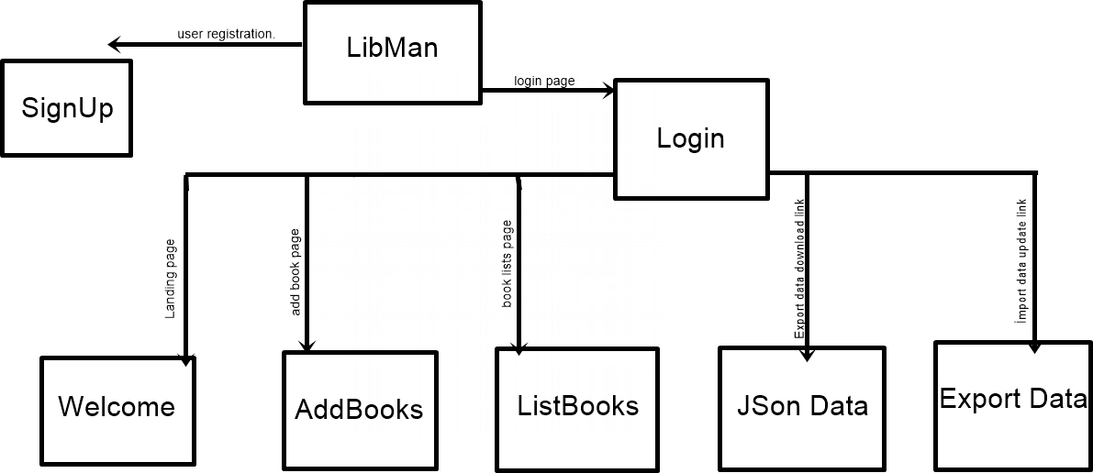

2.4-Class Diagram ;
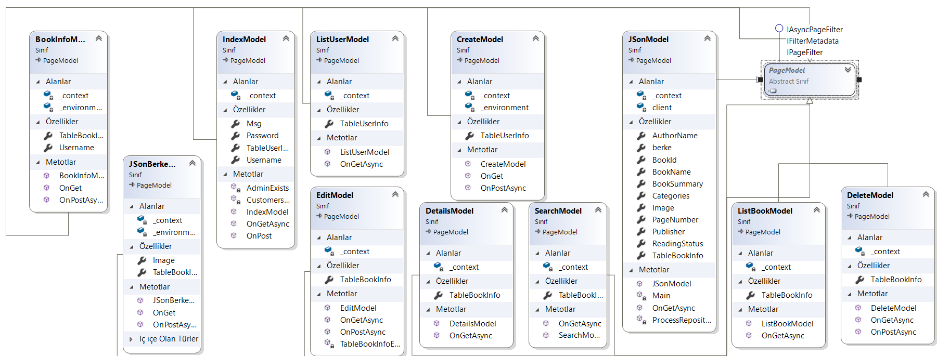

3-Project Results

3.1-Login Page

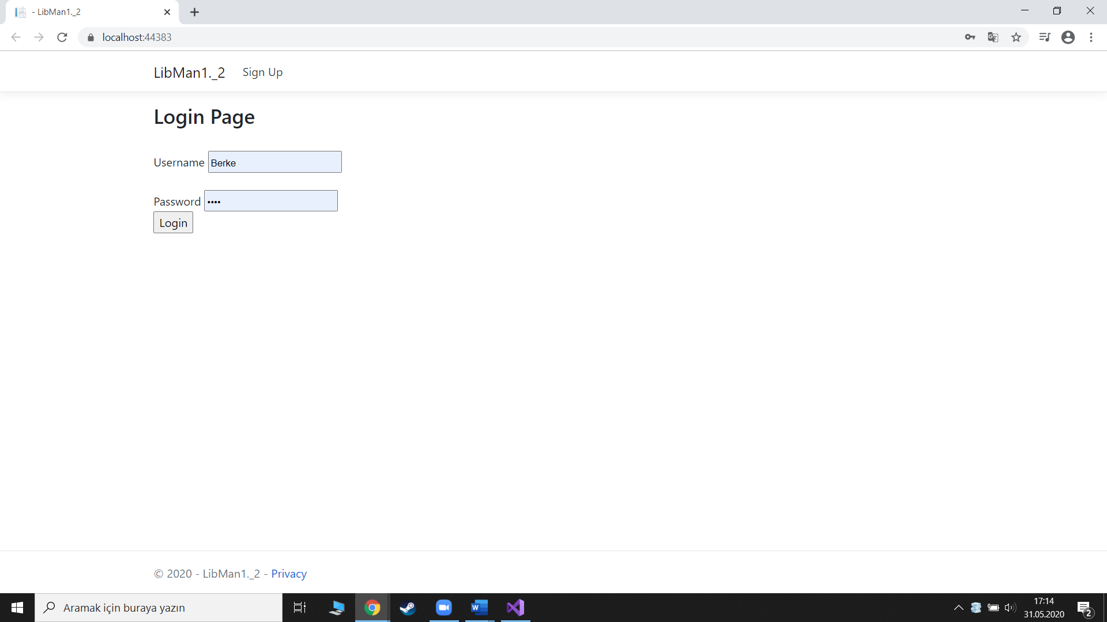

The registered user is required to login on this page in order to access his / her profile, book lists and book addition.

3.2-Sign Up Page

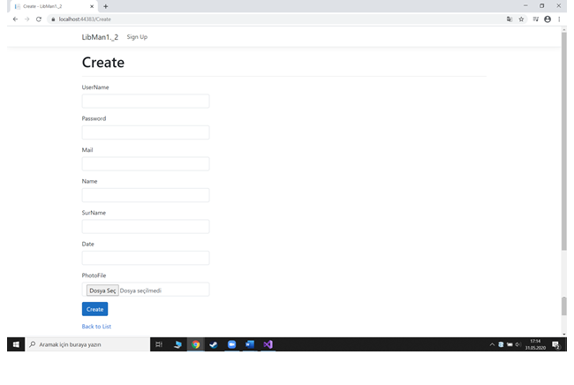
Users who are not registered should create a profile and register by entering information such as username, name, surname, date of birth and photograph from this page.

3.3-Welcome Page

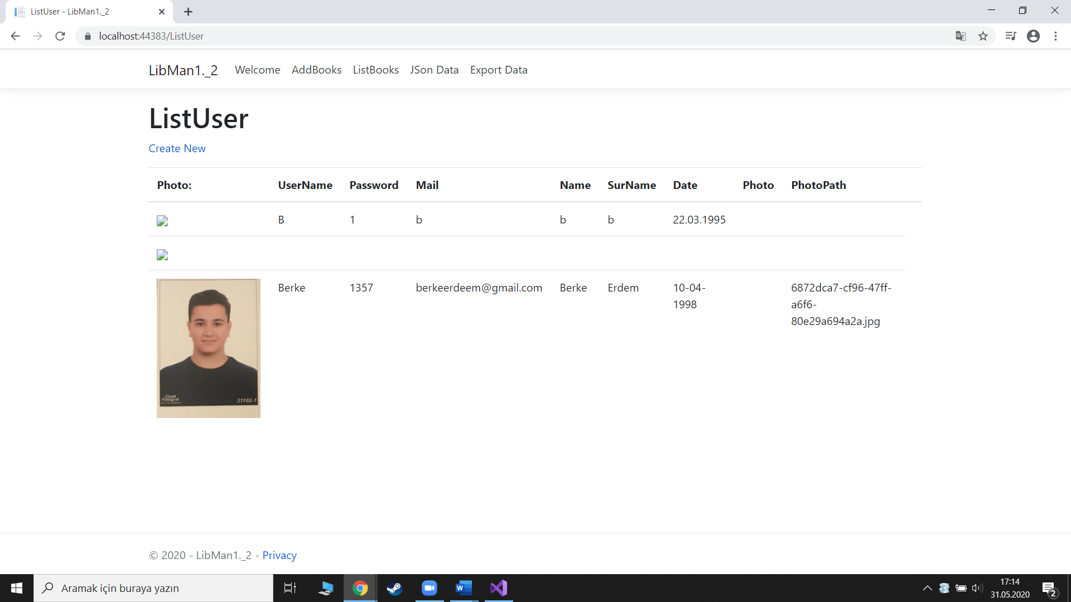

Welcome page that you will come across after logging in from the login page. On the welcome page, you will be able to access the information of users who have already
registered on the site and your own information.

3.4-Add Books Page

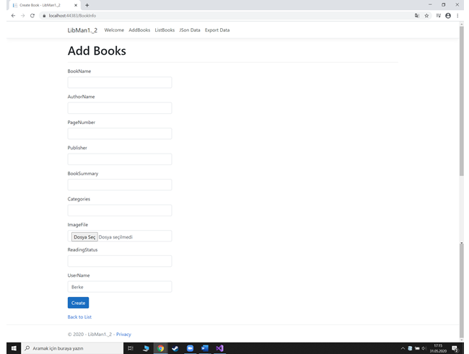

After the welcome page, there will be many page options. One of them is the Add books page. After entering the name, author, page number and similar information of the book you want to add from this page, you will add a new book for your profile by specifying your reading status.

3.5-List Books Page

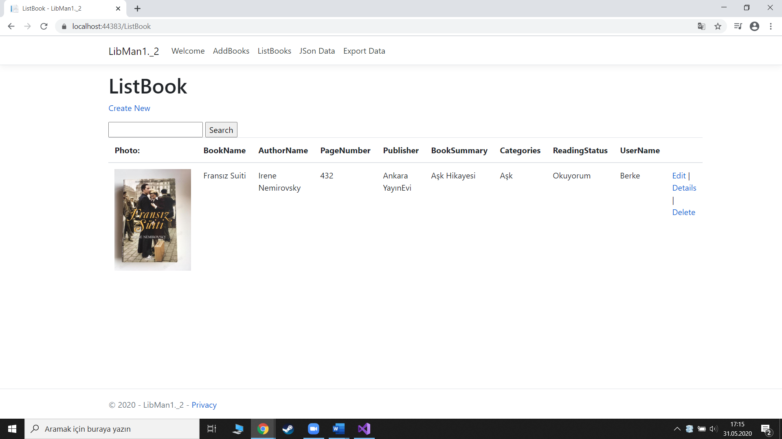
One of the page options is the list books page. On this page you can see the information of the books you have already added. You can delete the books you added, correct them if you want.

3.6-JSon Download Button
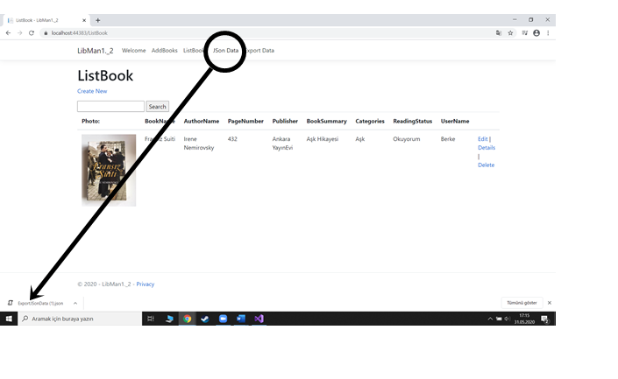
JSon Data acts as a button, not a page. After clicking on Json data, you will convert the books in your list to Json data and start downloading automatically.

3.7-Export Upload Page

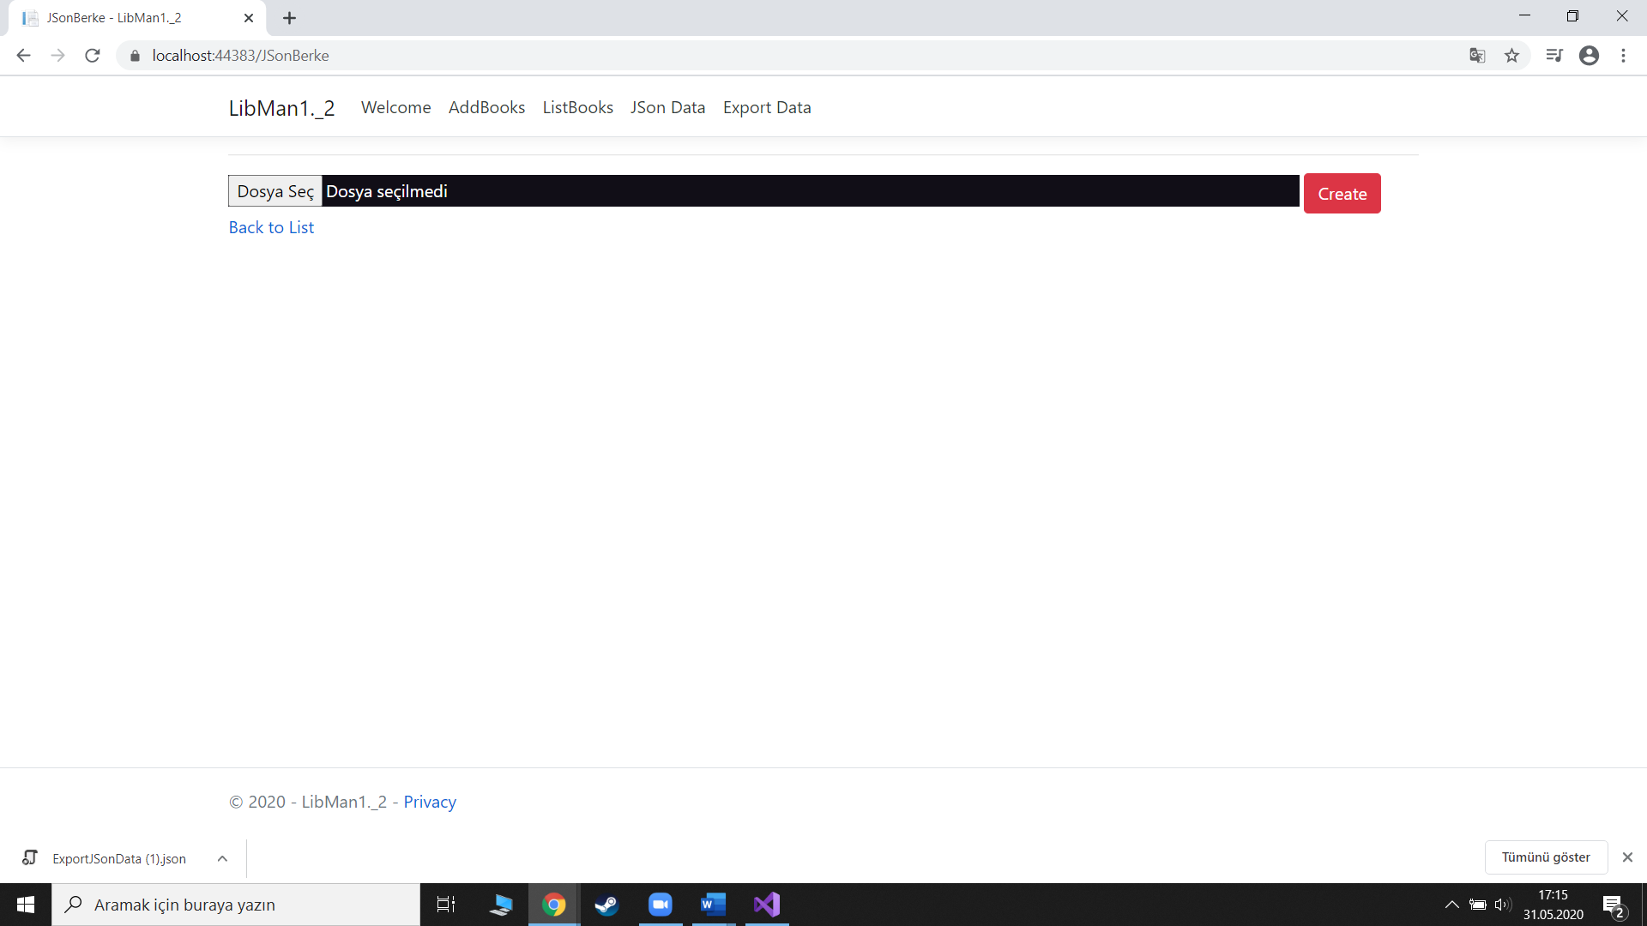

It is the last page on the Export Data website. Export data performs the opposite operation according to the Json Data page. It takes the Json data file you select from your computer and automatically adds the information of the books in it to your list.

4-Conclusions

On this website, we have acquired some basic concepts, themes and skills related to reading books.

If you decide to read more books, this website is the basic knowledge, understanding and analysis you need to note their purposeful books in an individual context, an organization you are familiar with. The website will also give you the opportunity to investigate emerging trends in book reading and to conduct independent research on books related topics that interest you.

